# Day 3 - Software Restriction GPO

**Create a new GPO**
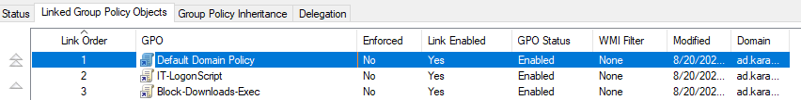

**Edit the GPO:**
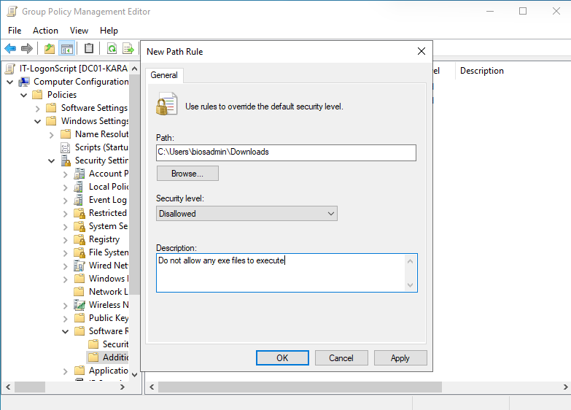
**Apply and test.** 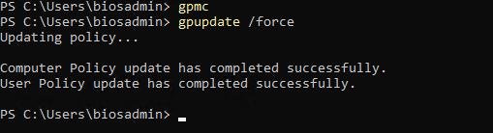
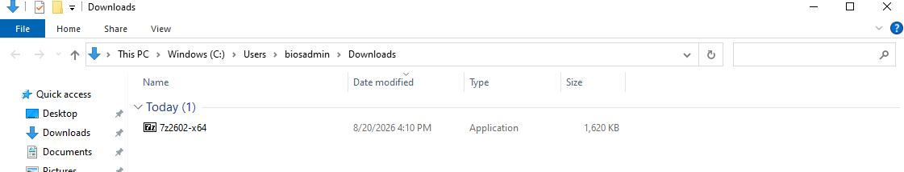
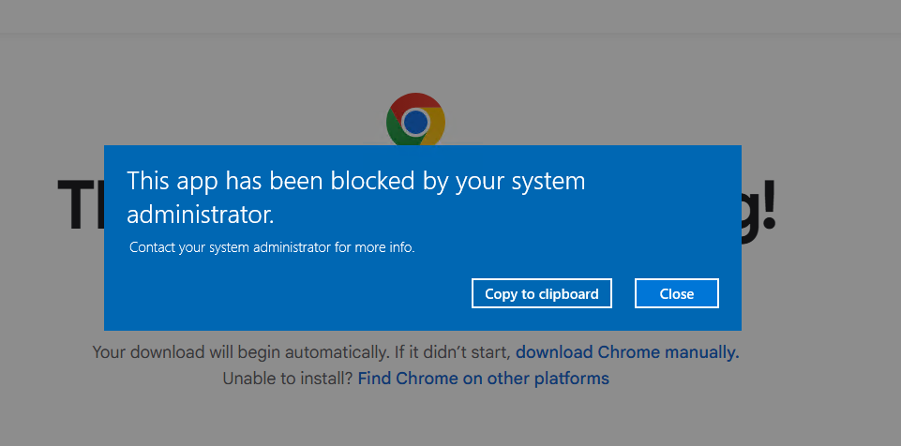
**Note the "why" in one line for the write-up:**
Many users fall into the trap of mistakenly executing exe files that might contain malware or fall victims to fishing, with this kind of policy enforced it lowers the chance of apps like this executing allowing malicious acters to gain initial access

## Why this matters
Shows understanding of endpoint hardening beyond just password policy.

## Skills covered
Software Restriction Policy path rules, OU-scoped endpoint hardening, GPO testing methodology (apply, then verify the actual blocking behavior, not just that the GPO linked).

